|  |  |  |  |  |  |  |  |  |  |  |  |  |  |  |  |  |  |  |  |
| --- | --- | --- | --- | --- | --- | --- | --- | --- | --- | --- | --- | --- | --- | --- | --- | --- | --- | --- | --- |
|  | 罸 |  | |  | •罸엇엇 | •罸 | •罸 | •罸 | •罸 | •罸 | E    0 0 | E  0  0 | •邑  E  0 | •罸•罸  E    0 0 | •罸  E  0  0 | E  cd  0 | •罸•罸  E    0 0 | E | •罸    0 |
|  |  |  | 등 등 넣 芼 넣 |  |  | cd  0  ℃ | ℃ |  | 0 •三 •三 •三 | •弓 •弓 | •石  0  •亐  0 0 髮 | •三•三  •乙•乙  0 0 髮 | 0  0 0  髮 | •三  •乙•乙  口 0  0 0 髮 | •芢 •芢  0  口 0 0 髮 | 0  口 0 0 髮 | •三  •乙•5  0  0 0 髮 | •三  0  0  0  髮 | •石  0  0  0 쇨 |
| 4 |  |  |  |  |  |  | (지 | 卜 |  |  | 0 이  0  이 | 寸 0  卜 0  0 | 寸 0  卜 0  0 | 0  00 | 0  0  이 | 61 | 0 이  0 |  |  |
|  | 국 |  | 6 名 품 岧 은  b  2 0 2 | 드 |  | 0  ; |  | 0 |  |  |  | 豸 트 % 岧 2 名 훞 턺 名 ! 은 薯 겉 毛 | 0  ℃  견 을 2 트 결 8 8 스 들 § ! 戔 글 | 8 트 듢 프 璧 음 5 .듬 |  | 0    Z | 「,」 |  |  |
|  |  |  |  |  |  |  |  |  |  |  |  |  |  |  |  |  |  |  |  |

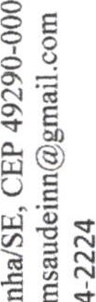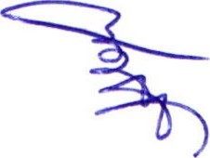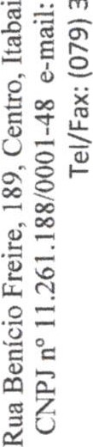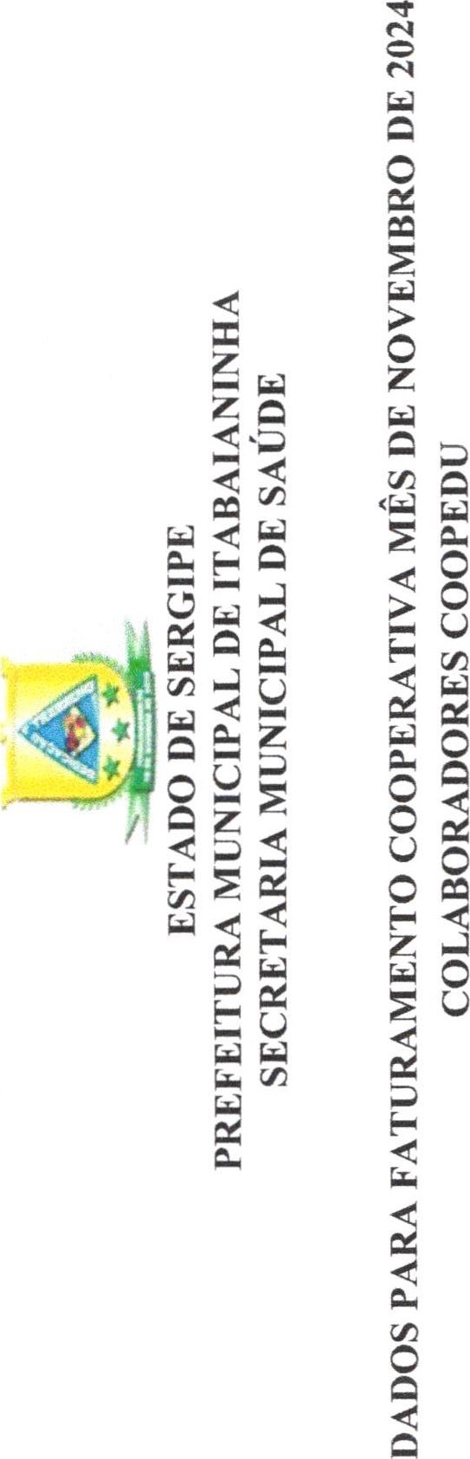•言耄 噏

|  |  |  |  |  |  |  |  |  |  |  |  |  |  |  |  |  |  |  |  |  |  |  |  |  |  |  |  |  |  |  |  |  |  |  |  |  |  |  |  |  |  |  |  |  |  |  |  |  |  |  |  |  |  |  |  |  |  |  |  |  |  |  |  |  |  |  |  |  |
| --- | --- | --- | --- | --- | --- | --- | --- | --- | --- | --- | --- | --- | --- | --- | --- | --- | --- | --- | --- | --- | --- | --- | --- | --- | --- | --- | --- | --- | --- | --- | --- | --- | --- | --- | --- | --- | --- | --- | --- | --- | --- | --- | --- | --- | --- | --- | --- | --- | --- | --- | --- | --- | --- | --- | --- | --- | --- | --- | --- | --- | --- | --- | --- | --- | --- | --- | --- | --- |
|  | |  |  |  |  |  |  |  |  |  |  |  |  |  | | --- | --- | --- | --- | --- | --- | --- | --- | --- | --- | --- | --- | --- | |  |  |  |  |  |  |  |  |  |  |  |  |  | |  | 3 | 2- |  |  | o    o | o    o | o | o    o | o    o | o    2.2 | o    ε.Ι2  ο | o    o    c | |  |  |  |  |  |  |  |  |  |  |  |  |  | |  |  |  |  |  |  |  |  |  |  |  |  |  | |  |  |  |  |  |  |  |  |  |  |  |  |  | |  |  |
|  |

